Homework 6

Amin Baabol

11/09/2020

### Problem 5.2:

Consider the time series data shown in Table E5.1

1. Make a time series plot of the data.

### Part 5.2a

The time series data as indicated by its plot show random variation pattern that does not seem to have have a repeating interval. There also might possible outliers at period 2 and 38.

#Raw data  
Period <- seq(from = 1, to = 50, by = 1)  
yt <- c(29,20,25,29,31,33,34,27,26,30,  
 29,28,28,26,27,26,30,28,26,30,  
 31,30,37,30,33,31,27,33,37,29,  
 28,30,29,34,30,20,17,23,24,34,  
 36,35,33,29,25,27,30,29,28,32)  
  
#Create a data frame  
Table.E51 <- data.frame(Period,yt)  
  
#Convert the dataframe into time series  
timeseries.data <- ts(Table.E51[,2])  
  
#Plot time series  
plot(timeseries.data,  
 main = "Time Series Plot of Table-E5.1 Data",  
 ylab = "yt",  
 xlab = "Period",  
 col = "navyblue")  
points(timeseries.data,pch="*", col = "red")

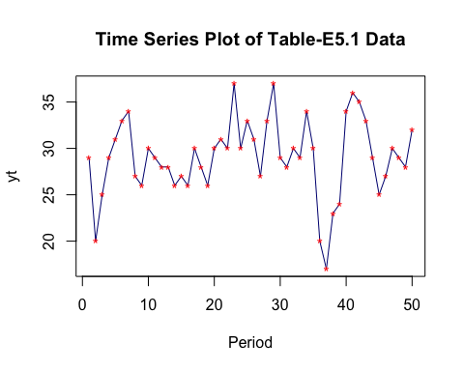

1. Calculate and plot the sample autocorrelation and PACF. Is there significant autocorrelation in this time series?

### Part 5.2b

There are some short runs where successive observations tend to follow each other for very brief durations,suggesting that there is might be some autocorrelation in the data. The ACF plot shows significant spikes at lags 1 and 4. Also,the sample ACF cuts off after lag 4 indicating that lag 1and 4 might be autocorrelated. On the other hand, The partial autocorrelation plot tails off although it has statistically significant spikes at lags 1,4,7.

library(forecast)

## Registered S3 method overwritten by 'quantmod':  
## method from  
## as.zoo.data.frame zoo

library(ggplot2)  
sample.acf <- ggAcf(timeseries.data,lag.max = 15)+labs(title = "ACF")  
sample.pacf <- ggPacf(timeseries.data,lag.max = 15)+labs(title = "PACF")  
  
#Calcuation  
ACF.calculation <- acf(timeseries.data, plot = FALSE)[1:15]  
PACF.Calculation <- pacf(timeseries.data, plot = FALSE)[1:15]  
ACF.calculation

##   
## Autocorrelations of series 'timeseries.data', by lag  
##   
## 1 2 3 4 5 6 7 8 9 10 11   
## 0.484 0.051 -0.161 -0.362 -0.216 0.071 -0.040 -0.059 -0.030 -0.085 -0.038   
## 12 13 14 15   
## 0.018 -0.095 -0.147 -0.104

PACF.Calculation

##   
## Partial autocorrelations of series 'timeseries.data', by lag  
##   
## 1 2 3 4 5 6 7 8 9 10 11   
## 0.484 -0.240 -0.105 -0.294 0.127 0.129 -0.333 0.007 -0.007 0.007 -0.104   
## 12 13 14 15   
## -0.092 -0.083 -0.133 -0.047

#plots  
sample.acf

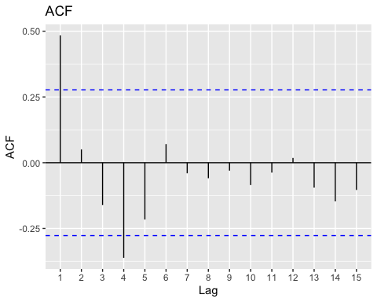

sample.pacf

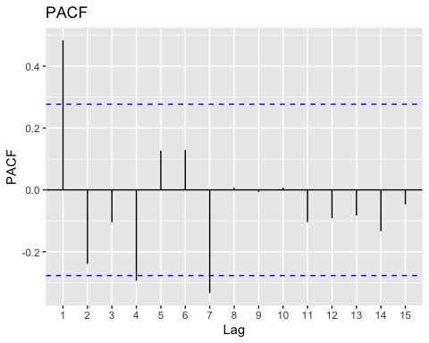

### Problem 5.5:

Consider the time series model yt = 150 − 0.5yt−1 + 𝜀t

1. Is this a stationary time series process?

### 5.5a

Yes, this AR(1) model is stationary because |phi| which is |-0.5| is less than 1.

1. What is the mean of the time series?

### 5.5a

The mean for this AR(1) model is 100

mu.AR1 <- 150/(1-(-0.5))  
mu.AR1

## [1] 100

c)If the current observation is y100 = 85, would you expect the next observation to be above or below the mean?

### 5.5c

If the current observation y100 is 85 I would expect the next observation y101 to be above the mean as explained by the calculation below.

yt = 150 − 0.5yt−1 + 𝜀t

y0 <- 150  
y100 <- 85  
y101 <- 150 - 0.5*85  
y101

## [1] 107.5

### Problem 5.7

Consider the time series model yt = 20 + 𝜀t + 0.2𝜀t−1

1. Is this a stationary time series process?

### 5.7a

This model is an MA(1) process with a constant mean, therefore it is stationary.

1. Is this an invertible time series?

### 5.7b

Yes, it is invertible because the MA parameter theta has an absolute value of |0.2| which is less than 1

1. What is the mean of the time series?

### 5.7c

The mean, mu is 20.

1. If the current observation is y100 = 23, would you expect the next observation to be above or below the mean? Explain your answer.

According to the MA model we not only need to know the mean and the current observation but we also need to know the previous error in order to predict whether the next observation is going to be above or below the mean(20).

### Problem 5.8

Consider the time series model yt = 50 + 0.8yt−1 + 𝜀t − 0.2𝜀t−1

1. Is this a stationary time series process?

### 5.8a

This model is an ARMA(p,q) process. Its stationarity depends on the AR component. The root m1 which |phi1| or |0.8| is less than 1.Therefore, it is stationary.

1. What is the mean of the time series?

mu.ARMA <- 50/(1-0.8)  
mu.ARMA

## [1] 250

1. If the current observation is y100 = 270, would you expect the next observation to be above or below the mean?

### 5.8c

y101 = 50 + 0.8*270 + t − 0.2𝜀t−1

According to the ARMA model equation, predicting whether the next observation is going to be above or below the mean involves knowing the previous error.Until we are able to find the previous error we will not be able to tell whether the next observation will be above or below the mean.

library(tinytex)  
delta = 50  
phi = 0.8  
theta = -0.2  
simulated.ARMA = arima.sim(list(ar = phi,ma = theta), n = 120) + delta/(1-phi)  
#Time series plot of y(t)  
par(mfrow = c(1,1))  
ts.plot(simulated.ARMA,  
 ylim = range(min(simulated.ARMA),270),  
 ylab = 'yt',  
 main = 'Time series plot',  
 type = 'o')  
abline(h = 250,col = "blue")  
points(100,270,col = "red")

